Team Spaghetti  
Katharine Brinker  
Glorio Yulianto  
Jannette Pham-Le

**CS157B Spring 2015: Team Project**

I. Description

Our dimensional model represents a business of grocery stores. One row in the fact table represents the transaction information in a day for a product from one store.

**Business Process:** Grocery sale transactions **Grain:** Transactions in a day for a product in one store  
**Dimensions:** Product, Promotion, Time, Store  
**Facts:** Dollar Sales, Unit Sales, Dollar Cost, Customer Count

II. Star Schema

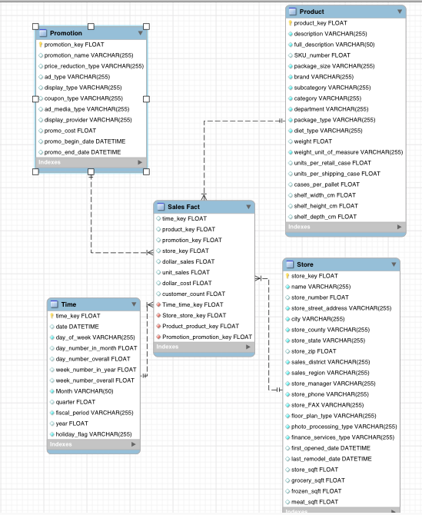

III. Screenshots

1) Initial screen that shows dimensions and attributes

2) Base cube

3) Roll-up operation on the base cube

4) Drill-down operation on the base cube

5) Slice operation on the base cube

6) Dice operation on the base cube